Assignment 2
Question 1) write following computer networking command with their usage
- Ipconfig
ipconfig is a Windows command-line utility used to display, verify, and manage the IP configuration of a computer’s network interfaces. It provides detailed information such as the IP address, subnet mask, default gateway, DNS servers, and the status of network adapters. The command is widely used by system administrators and users for network configuration, diagnostics, and troubleshooting connectivity issues.
It shows:
- IP Address
- Subnet Mask
- Default Gateway
- Network adapter details
Syantax
ipconfig [options]

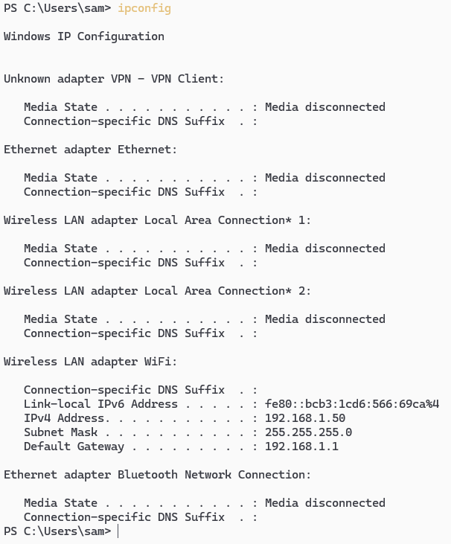

- Hostname
hostname is a command-line utility used to display or identify the name of a computer (host) on a network. The hostname uniquely represents a system and is used by operating systems, network services, and administrators to identify, manage, and communicate with devices within a local network or over the internet.

Syntax:
hostname
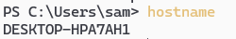

- Route print
route print is a Windows networking command used to display the system’s IP routing table. It shows how network packets are directed from the local computer to different networks by listing destination networks, subnet masks, gateways, interfaces, and routing metrics. This command is commonly used for network analysis and troubleshooting routing-related issues.

Syntax:
route print

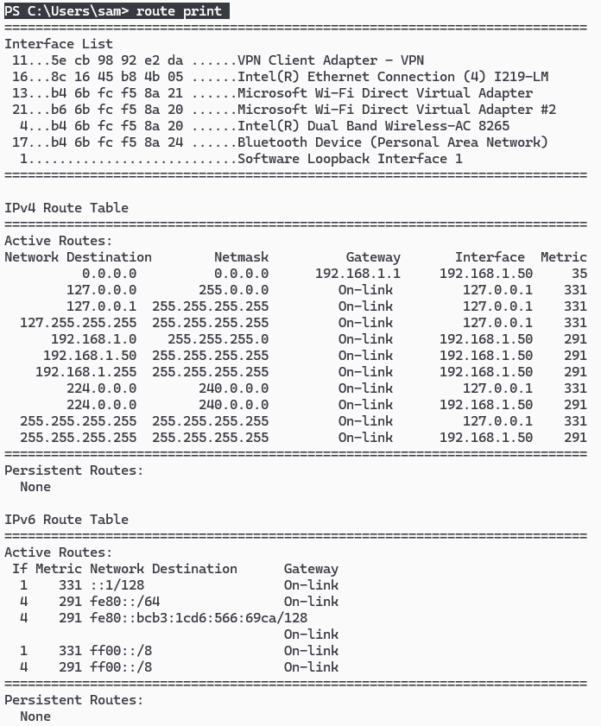

- Ping
ping is a network diagnostic command used to test the reachability of a host on an IP network and to measure the round-trip time taken for data packets to travel from the source to the destination and back. It works by sending ICMP Echo Request messages and receiving Echo Reply messages, helping to identify network connectivity, latency, and packet loss.

Syntax:
ping <destination>
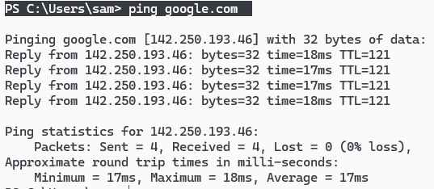
- Nslookup
(Name Server Lookup) is a network administration command-line tool used to query Domain Name System (DNS) servers to obtain domain name or IP address mapping information. It helps verify DNS resolution, identify DNS server issues, and troubleshoot problems related to name-to-IP or IP-to-name translation.

Syntax:
nslookup [domain-name | IP-address]
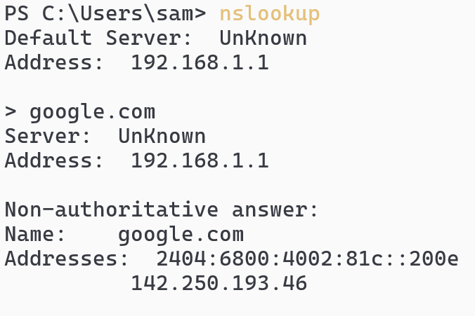
- Tracert
tracert (Trace Route) is a Windows network diagnostic command used to track the path taken by data packets from the local computer to a destination host. It displays each intermediate router (hop) along the route and the time taken to reach each hop, helping identify network delays, routing problems, or unreachable nodes.

Syntax:
tracert <destination>
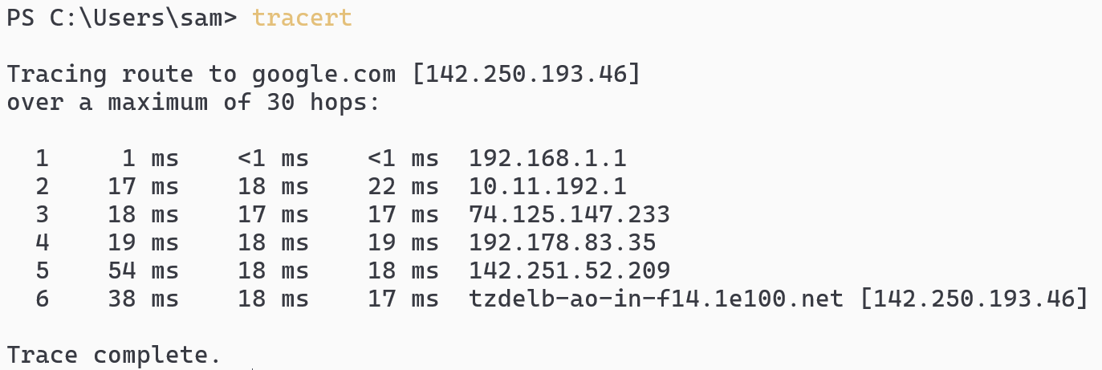

- Arp –a
arp -a is a network command used to display the Address Resolution Protocol (ARP) cache of the system. It shows the mapping between IP addresses and their corresponding physical (MAC) addresses for devices that the computer has recently communicated with on the local network. This command is commonly used for network monitoring, troubleshooting, and detecting IP–MAC conflicts.

Syntax:
arp -a
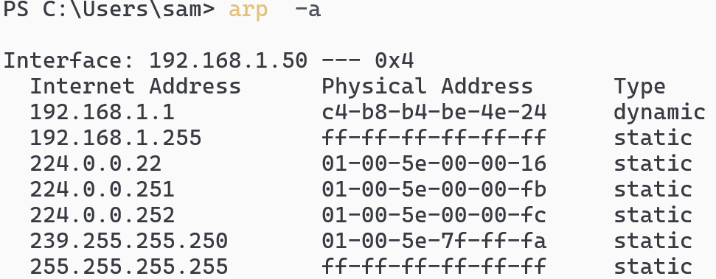
- Netstat –a
netstat -a is a network diagnostic command used to display all active network connections and listening ports on a computer. It provides information about TCP and UDP connections, including ports that are currently open, established, or waiting for connections, making it useful for monitoring network activity and troubleshooting connectivity or security issues.

Syntax:
netstat -a

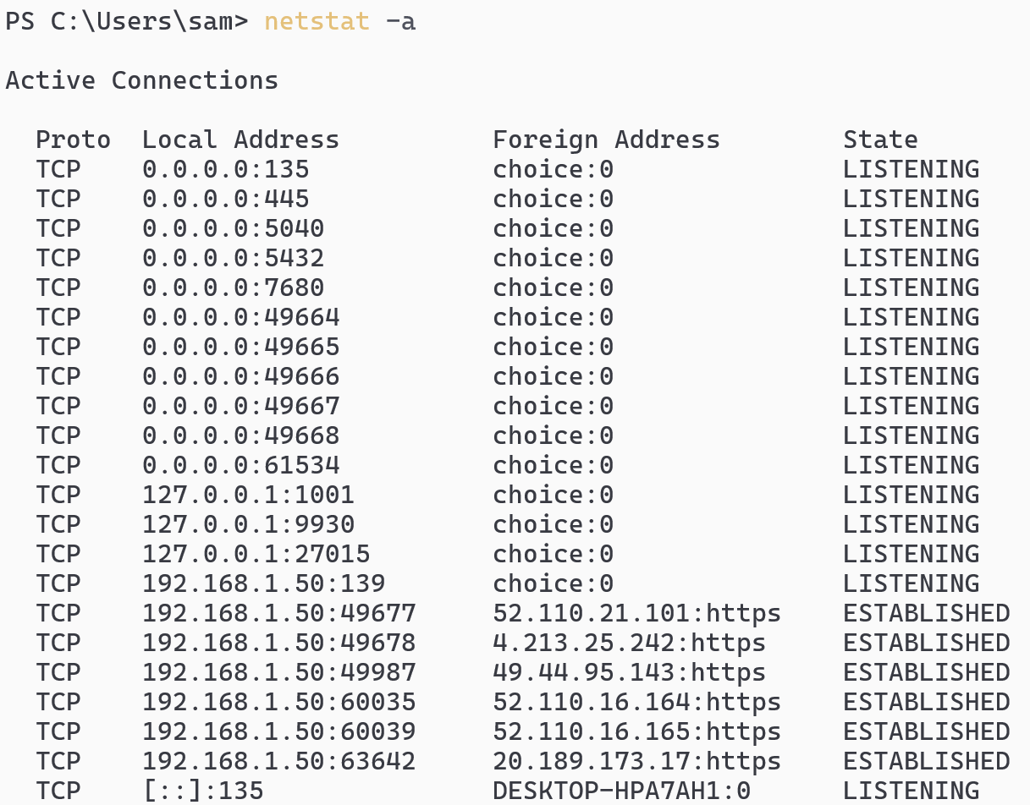

- Getmac
getmac is a Windows command-line utility used to display the Media Access Control (MAC) addresses of all network interfaces present on a system. It shows the physical (hardware) address assigned to each network adapter, which is essential for network identification, configuration, and troubleshooting.

Syntax:
getmac

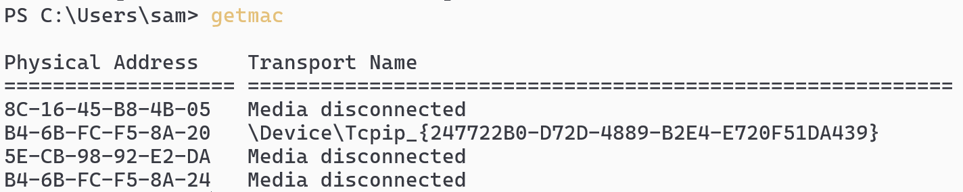

- Netstat
netstat (Network Statistics) is a network diagnostic command-line tool used to display network connections, routing tables, interface statistics, and protocol information on a system. It helps administrators and users monitor network activity, identify open ports, and troubleshoot network and performance issues.

Syntax:
netstat

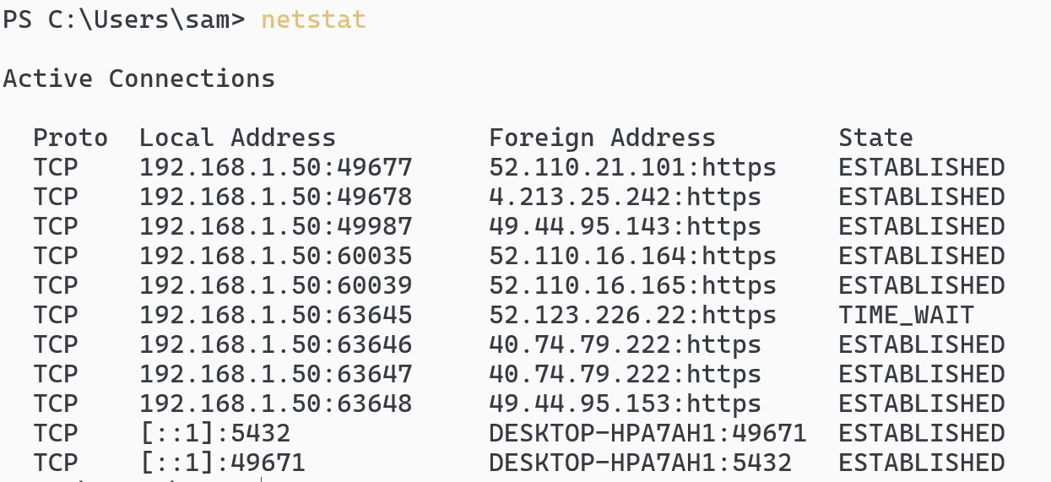

- Systeminfo
systeminfo is a Windows command-line utility used to display detailed configuration and hardware information about a computer system. It provides comprehensive data such as the operating system version, system manufacturer, processor details, installed memory (RAM), BIOS version, system uptime, and installed hotfixes, making it useful for system administration, auditing, and troubleshooting.

Syntax:
systeminfo
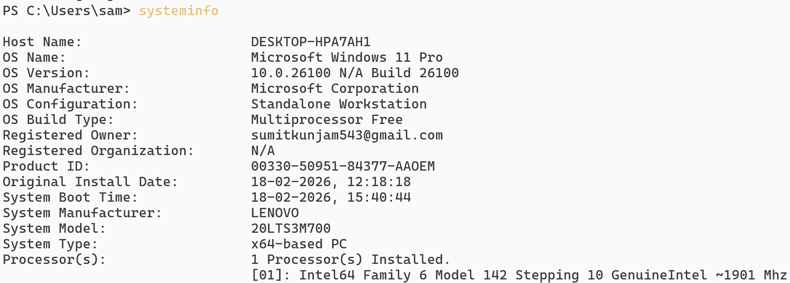

- Pathping(alternative of tracert)
pathping is a Windows network diagnostic command that combines the functionality of ping and tracert. It identifies the route taken by packets to a destination host and then performs statistical analysis of packet loss and latency at each hop. This makes it especially useful for detecting network congestion, unstable links, and packet loss problems over time.

System
pathping domain_url
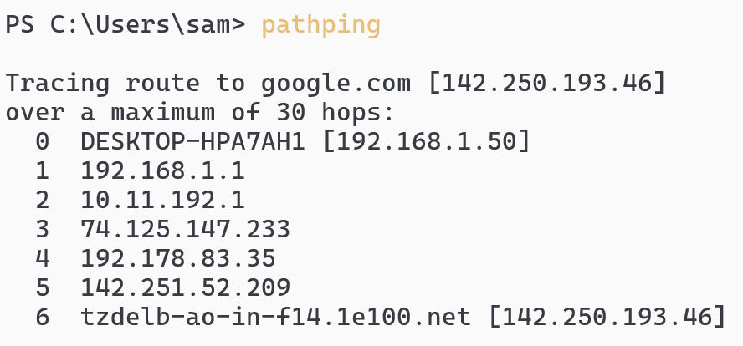

- Curl
curl (Client URL) is a command-line tool used to transfer data to or from a server using various network protocols such as HTTP, HTTPS, FTP, and more. When used with a domain name, it sends a request to the specified server and retrieves the server’s response, commonly to test web connectivity, fetch web pages, or inspect API responses.

Syntax:
curl domain_url
